- Rialik` kv ku5 rikni tin jsak:
- Caa jv nyusth v riet.
    - Kv gu11th vn jsak baa Cvy-t1n nh6k f66 bv ti g1ykv naath ti thu]]k l1t k` bv m00tni ti /caa dee lu`x kv m5 xivc kv kv k` /caa dee lu`x kv g1k l1t (Nyuuth. 13:13-14; M0-thiw. 24:24).
    - V ni x`c Bay-bol min thusk k` luex, kv lu`k Yi22k` min Gsaa in Rvl Rs, v jvn dee ksn jak k` xot kv cu]x v bum rvy thuk` ms (2 Pi-tsr. 1:19-21).
- Caa kv b55l Nhiam kaandivn.
    - Th``ny Kusth x1c kv jv kv dup d1x disk:
      - Y522 in Gsaa in Rvl Rs. Baa j5 x`th` rv r5cni diaal b55l kv jv (V-pv-th`th. 4:30).
      - Ci6t, kiv ciax Kusth. Bv t` kv nvy diaal tin bi t5`m (Nyuuth. 14:1; 22:4).
      - V bivl mi lu1xkv kv xi`c (Nyuuth. 9:4; Yɛdh-ki-el. 9:4).
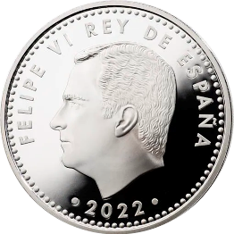
    - Kuoth cv th55lv l1th rvy xutd` kvl k` xut d1x w`l, v la bivl m5 nyooth nvy tin pal kv jv (Yɛdh-ki-el. 20:20).
G5-r5cni 10 Yu-r6 kv ku5 t5m` run` matd` m5n 20

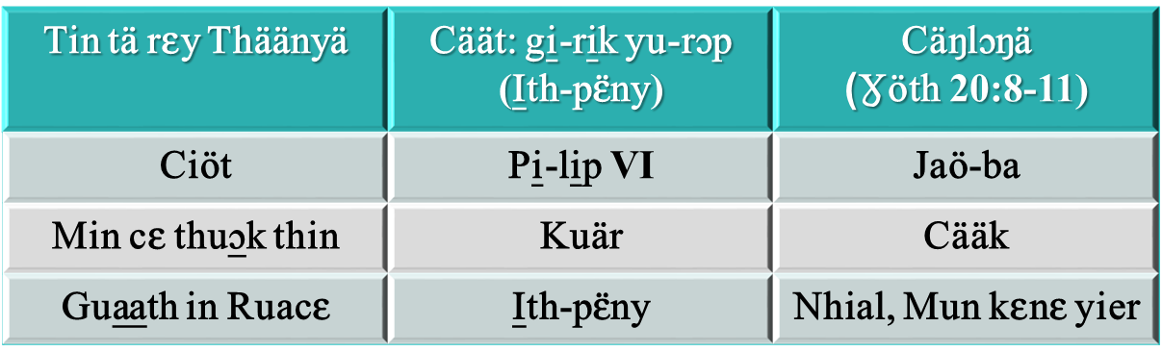
    - Vn th55l, bivl kiv th``ny jek kv jv kv dup d1x rvw ti t` kv d``k: kv nhiam kaan kiv tet. Gu11th vn bi j5 x`th` jv jek kv nhiam kaandivn, bi nvy tin thivl x1th jv jek kv nhiam kaandivn kiv kv tetdivn (Nyuuth. 13:16). V xu la d``kdivn s?
      - Nhiam kaan: CU}P LSAAC X~C~ XSAANI. X`th ksn ni ram min pal ksn v
      - Tet: MIN G^R LSCV (p11y). Pal ksn kv dualan kv min bi ksn j`k
    - Cvy-t1n /cv divvr kv lust pal`, duxdv f66 Kuoth nhskv ni pal vn b` ni rvy lsaac min lust kv ni jv k` thi`x (R6m. 12:1).
  - Ram in x1thkv kv ku5 Pal`.
    - Nvy tin l6kv k`ni bivl` l00 thivlv mi bi kvn v ksk kiv mi dee kvn v ksak, k` baa kv duac dual kv li11 (Nyuuth. 13:15-17). Kv ku5c vn dsx, m5 ci kvn v nhsk bi kvn cuuc kv r5k tin jsak kvnv “li1 in rvwdv”, bi kvn tek in d7raar cu b1th (Nyuuth. 16:2 ; 14:9-11; 20:4, 13-15).
    - M5 c`xlsx` v nyuuth (bivl) mi jsc kv ku5 x`th`, /ci bivl l00 te kv jvn t11 vmv b`?
    - Kv f66 thivlv mi ci Bay-bol v lat kv ku5 g2r` c`x pal`, nh6k ran kv c`x in ji6l v la c`x pal` nhsk raan ni lu1x ci6c` min gvvr c`x (Min caa lat v la 666).
    - V lu1x vn m5th dee ksn v kulv nhsk s? v lu1x naath kiv lu1x Kusth, min cv nyoth v jsc rvy rieet ni kv?
- Lu1x m5 b` nhial:
  - Nhial in jsak.
    - Ci g7k ni Yo-el ruac kv ku5 nhial v la c``t kv ben Y522k` min gsaa in Rvl rsdv (Yo-el 2:23, 28). Nvmv b` v jvn du]]p ee ci Pi-tsr v lat kv jv rvy ruacdv kv c`x n5n5 jivn dhieec (L`t 2:14-17).
    - C3tkv mee caa Ci6c yiath piny kv nhial Yi22k` min gsaa in rvl rs, lat thukni Kusth tin gsw kv gu11th in jsak, min la x2r in jsak, bv rsdv l11t kv ksr k` min caa nath wu]c nhial in jsak: baa Yi22 in Gsaa in rvl rsdv wu]c j5 x`th` r5c` min jsak kv lu1x mi diit (Nyuuth. 18 :1).
  - Lat thukni Kusth ti Gsw.
    - Bi Y522 in Gsaa in Rvl rsdv ben piny k` j5 x`th` kv lu1x mi diit nvy “tin ka̱pkɛ ŋuɔ̱t Kuɔth kɛnɛ ŋa̱th Yecu” (Nyuuth. 14:12), nvy tin latkv thuk Kusth tin gsw, kvvl kv lu2k tuk` lusk, kvnv ci66l pal` C``k` (Nyuuth. 14:6-7).
    - Kv r6m naath kv kvn thuk titi, v tvthlsaac tekv lu1x nhial in jsak, bi nvy diaal r6m kv mek k11m xsaani d1x rvw: v f66 bi raan th``ny Kusth nhsak kiv bivl l00 (Nyuuth. 14:9-11).
    - Bi ji77th ti xuan ruac in jsak lat. Bi nvy ti xuaan mvk ni f66 bi kvn x1thdivn rsam thin a bum m`ni guut.

